Database Schema Documentation
Flight Delays and Weather Impact Analysis at CVG
Stefanie Collier
stefaniecollier91-coder/Data-Engineering-Pipeline-Project

1. Project Overview
This database supports an end-to-end data engineering pipeline and Power BI dashboard for analyzing how weather conditions affect flight delays, cancellations, diversions, and monthly flight performance at Cincinnati/Northern Kentucky International Airport (CVG). The project integrates BTS TranStats airline performance data with Open-Meteo weather data.

2. Database Design Summary
- The schema uses PostgreSQL and separates reference, fact, weather, and ETL tracking data.
- Monthly flight performance is stored in flight_monthly_performance and joins to airport, airline, and date_month.
- Daily weather observations are stored in weather_daily and can be summarized by month for comparison with flight performance.
- The reporting view vw_monthly_flight_weather_summary is designed for Power BI dashboard use.

3. Entity Relationship Diagram
The ER diagram below shows the major tables, primary keys, foreign keys, and one-to-many relationships used in the database.
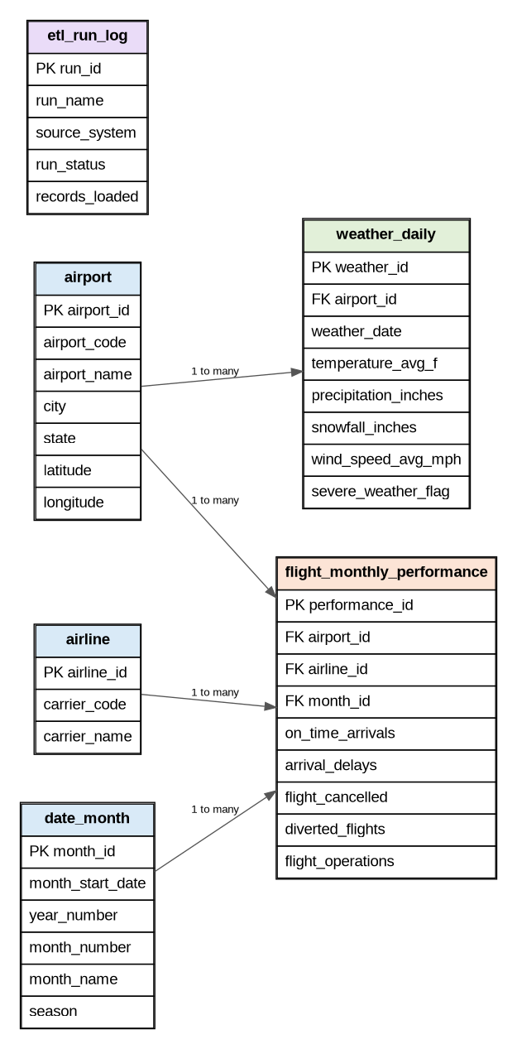

4. Table Definitions

Table: airport
Purpose: Stores airport reference information. This project focuses on CVG, but the structure supports adding more airports later.
Column Name | Data Type | Key / Constraint | Description
airport_id | SERIAL / INTEGER | Primary Key | Unique airport record identifier.
airport_code | VARCHAR(10) | Unique, Not Null | Airport code such as CVG.
airport_name | VARCHAR(150) | Not Null | Full airport name.
city | VARCHAR(100) | Optional | Airport city or nearby city.
state | VARCHAR(50) | Optional | State where the airport is located.
country | VARCHAR(50) | Default USA | Country value for airport location.
latitude | NUMERIC(9,6) | Optional | Latitude coordinate used for weather API matching.
longitude | NUMERIC(9,6) | Optional | Longitude coordinate used for weather API matching.

Table: airline
Purpose: Stores airline or carrier reference information from BTS TranStats. The initial load uses an aggregate row for all marketing carriers.
Column Name | Data Type | Key / Constraint | Description
airline_id | SERIAL / INTEGER | Primary Key | Unique airline or carrier identifier.
carrier_code | VARCHAR(10) | Unique, Not Null | Carrier code, such as ALL for aggregate monthly data.
carrier_name | VARCHAR(150) | Not Null | Full carrier or aggregate carrier name.

Table: date_month
Purpose: Creates a monthly date dimension for joining monthly airline data and daily weather data summarized by month.
Column Name | Data Type | Key / Constraint | Description
month_id | SERIAL / INTEGER | Primary Key | Unique month record identifier.
month_start_date | DATE | Unique, Not Null | First day of the reporting month.
year_number | INTEGER | Not Null | Calendar year.
month_number | INTEGER | Not Null, 1-12 Check | Calendar month number.
month_name | VARCHAR(20) | Not Null | Month name used in dashboard labels.
season | VARCHAR(20) | Not Null | Season category for seasonal performance analysis.

Table: flight_monthly_performance
Purpose: Stores monthly BTS TranStats performance metrics for CVG, including on-time arrivals, delays, cancellations, diversions, and total operations.
Column Name | Data Type | Key / Constraint | Description
performance_id | SERIAL / INTEGER | Primary Key | Unique monthly performance record identifier.
airport_id | INTEGER | Foreign Key to airport | Airport connected to the monthly performance record.
airline_id | INTEGER | Foreign Key to airline | Carrier or aggregate carrier connected to the record.
month_id | INTEGER | Foreign Key to date_month | Reporting month.
on_time_arrivals | INTEGER | Not Null, >= 0 | Number of flights arriving on time.
on_time_pct | NUMERIC(5,2) | 0-100 Check | Percentage of flights arriving on time.
arrival_delays | INTEGER | Not Null, >= 0 | Number of arrival delays.
delayed_pct | NUMERIC(5,2) | 0-100 Check | Percentage of delayed flights.
flight_cancelled | INTEGER | Not Null, >= 0 | Number of cancelled flights.
cancelled_pct | NUMERIC(5,2) | 0-100 Check | Percentage of cancelled flights.
diverted_flights | INTEGER | Not Null, >= 0 | Number of diverted flights.
flight_operations | INTEGER | Not Null, >= 0 | Total monthly flight operations.
source_system | VARCHAR(100) | Default BTS TranStats | Identifies source system for lineage.
loaded_at | TIMESTAMP | Default current timestamp | Date and time the row was loaded.

Table: weather_daily
Purpose: Stores daily weather observations retrieved through Open-Meteo. These records can be aggregated monthly and compared with flight disruption patterns.
Column Name | Data Type | Key / Constraint | Description
weather_id | SERIAL / INTEGER | Primary Key | Unique weather record identifier.
airport_id | INTEGER | Foreign Key to airport | Airport connected to the weather observation.
weather_date | DATE | Not Null | Date of weather observation.
temperature_avg_f | NUMERIC(6,2) | Optional | Average daily temperature in Fahrenheit.
precipitation_inches | NUMERIC(8,3) | Default 0 | Daily precipitation total.
snowfall_inches | NUMERIC(8,3) | Default 0 | Daily snowfall total.
wind_speed_avg_mph | NUMERIC(6,2) | Optional | Average daily wind speed.
weather_condition | VARCHAR(100) | Optional | General weather description or condition category.
severe_weather_flag | BOOLEAN | Default False | Flags days with severe weather conditions.
source_system | VARCHAR(100) | Default Open-Meteo API | Identifies source system for lineage.
loaded_at | TIMESTAMP | Default current timestamp | Date and time the row was loaded.

Table: etl_run_log
Purpose: Tracks ETL pipeline runs, source systems, row counts, status, and notes for data validation and troubleshooting.
Column Name | Data Type | Key / Constraint | Description
run_id | SERIAL / INTEGER | Primary Key | Unique ETL run identifier.
run_name | VARCHAR(100) | Not Null | Name of ETL job or pipeline step.
source_system | VARCHAR(100) | Not Null | System or file loaded.
run_status | VARCHAR(30) | Not Null | Run status such as Completed, Failed, or Pending.
records_loaded | INTEGER | Default 0 | Number of records loaded by the ETL step.
started_at | TIMESTAMP | Default current timestamp | Start time for ETL run.
completed_at | TIMESTAMP | Optional | Completion time for ETL run.
notes | TEXT | Optional | Notes about errors, validation, or pending steps.

5. Key Relationships
Parent Key | Child Foreign Key | Relationship Description
airport.airport_id | flight_monthly_performance.airport_id | One airport can have many monthly flight performance records.
airline.airline_id | flight_monthly_performance.airline_id | One airline/carrier group can have many monthly performance records.
date_month.month_id | flight_monthly_performance.month_id | One month can have many performance records across airports or carriers.
airport.airport_id | weather_daily.airport_id | One airport can have many daily weather observations.

6. Power BI Reporting View
The SQL script creates vw_monthly_flight_weather_summary, which combines monthly flight performance with weather metrics aggregated by month. This view is intended to simplify dashboard creation in Power BI by providing one clean reporting table.

7. Submission Files
- database_schema_documentation.docx - written schema documentation and embedded ER diagram.
- er_diagram.png - standalone ER diagram image.
- initial_postgresql_load_script.sql - PostgreSQL script to create tables, load initial data, and create a Power BI reporting view.

